# Apply filters to SQL queries Project

**MUHAMMAD ALI KHAWAR BUTT**

## Project description

My organization has been working to make its systems more secure. I use SQL to filter large amounts of data using SQL using filters. These filters include keywords like WHERE and LIKE, etc.

## Retrieve after hours failed login attempts

There was a potential security threat that occurred after working hours, after 18:00. I used SQL to filter all the login attempts after 18:00 hours.

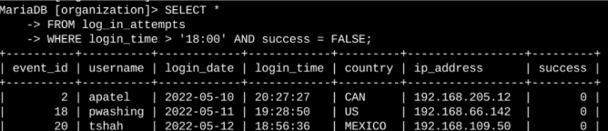

Here, the first portion shows the code and the second portion shows the result.

In the code:

Select *: selects all columns from the table.

FROM log_in_attempts: Specifies the table from which to fetch the data.

Where login_time >: Filters records so only those with the login date having **May 8** or **May 9, 2022,** are shown.

## Retrieve login attempts on specific dates

A suspicious activity occurred on the date 2022-05-09. I used SQL to filter the data around these dates.

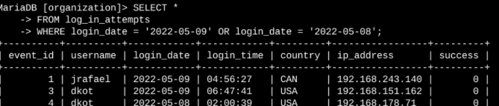

Here I used the OR operator to filter the data between the dates 2022-05-09 and 2022-05-08.

## Retrieve login attempts outside of Mexico

While investigating the organizations data on login attempts , a issue was found with login attempts outside of Mexico.

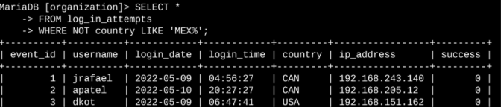

We used the NOT operator and the keyword LIKE to include all data entries with the keyword MEX and the % sign to add all characters after it.

## Retrieve employees in Marketing

To this end, I need to know which employees' computers need updating. My team has proposed renewing the machines of some employees in the Marketing department.

This is a code snippet that shows how I created a SQL query that filters for employee machines of those employees in the Marketing department situated in the East building.

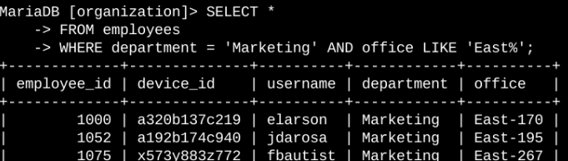

## Retrieve employees in Finance or Sales

Indeed, the machines for all employees in the Finance and Sales departments need updating. Since these departments require a different security update, I need to fetch information of employees from these two departments only.

The following code demonstrates how I created a SQL query to filter for employee machines from employees in Finance or Sales departments.

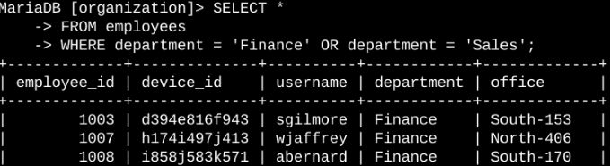

## Retrieve all employees not in IT

One more security update needs to be done for employees not in the Information Technology department, and I need to gather information about those employees prior to making the update.

The example that follows illustrates how I created an SQL query to filter for employee machines from employees outside the Information Technology department.

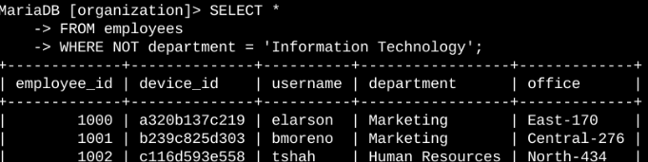

We used the NOT operator to remove the IT department

## 

## Summary

I applied filters to SQL queries to get specific information on login attempts and employee machines. I used different tables and used the AND OR and NOT operators to filter for the specific information needed for each task. I also used LIKE and the percentage sign (%) wildcard to filter for patterns.